Arapahoe Community College

CSC245 Project 3

Peer Review and Correction

Rylan Peterson

Issue | Authoritative Source | Specific vulnerability | Mitigation date
1 | Java Coding Guidelines, 75 recommendations for reliable and secure programs | Minimize the scope of variables | March 20,2022
2 | Java Coding Guidelines, 75 recommendations for reliable and secure programs | Do not declare more than one variable per declaration | March 20,2022
3 | Java Coding Guidelines, 75 recommendations for reliable and secure programs | Use meaningful symbolic constants to represent literal values in program logic | March 20,2022
4 | Java Coding Guidelines, 75 recommendations for reliable and secure programs | Use braces for the body of an if, for, or while statement | March 20,2022
5 | Java Coding Guidelines, 75 recommendations for reliable and secure programs | Do not place a semicolon immediately following an if, for, or while condition | March 20,2022
6 | Java Coding Guidelines, 75 recommendations for reliable and secure programs | Do not attempt to help the garbage collector by setting local reference variables to null | March 20,2022
7 | The CERT Oracle Secure Coding Standard for Java | FIO14-J. Perform proper cleanup at program termination | March 20,2022

Location of vulnerabilities

1. There was 2 locations where Issue 1 has been located:
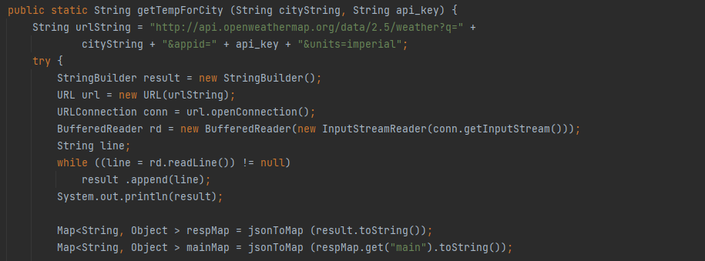
In this location line with “String line;” is not needed.
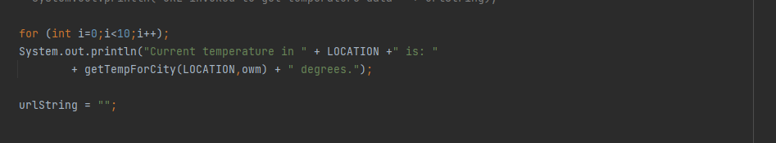
Line with (urlString = “”;) is not needed

2. There is only one location for Issue 2:
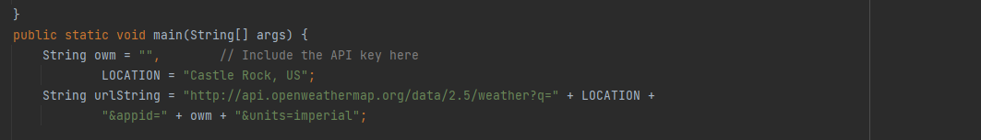
Line with (LOCATION = “Castle Rock, US”) should be on its own string because it is declaring more then one variable per declaration

3. There is only one location for Issue 3
Line with (String owm = “”,) “owm” should be changed to something like API_KEY because it use meaningful symbolic constants to represent literal values in program logic.

4.There is only one location for Issue 4
Line with (for (int i-0;i<10;i++);) should be removed because of incorrect Use of braces for the body of an if, for, or while statement

    - The only location for Issue 5 is the same as issue 4 above
Line with (for (int i-0;i<10;i++);) should be removed because you can not place a semicolon immediately following an if, for, or while condition

6.There is one location for Issue 6
Line with (while ((line = rd.redLine()) != null) should be removed because you shouldn't attempt to help the garbage collector by setting local reference variables to null

    - There is one location for issue 7
Line should be added saying (Runtime.getRuntime().exit(status:1);) should be added in so that the program exits after it prints to screen.

After fixing these issues the finished code should look like this :
